Requirements for the app:

* Microsoft PowerApps
* Microsoft Teams

We have used Microsoft PowerApps to develop our application. The app contains 4 screens ‘Start’, ‘maps’, ‘your area’ and a ‘chat bot’.

* The ‘start’ screen (fig. 1) has the app icon and name.
* ‘Maps’ screen (fig. 2) shows the users’ nearby area.
* ‘Your area’ screen (fig. 3) is a dashboard which shows the areas under threat, a safe house for the victims/survivors, etc.
* Last screen has a chat bot (fig. 4) which guides you to take necessary precautions during the time of a flood.

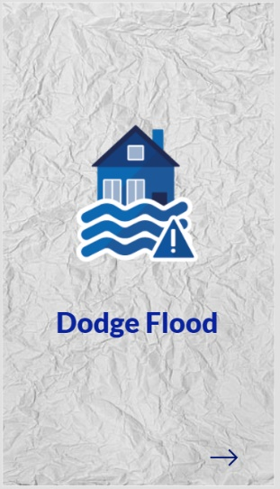

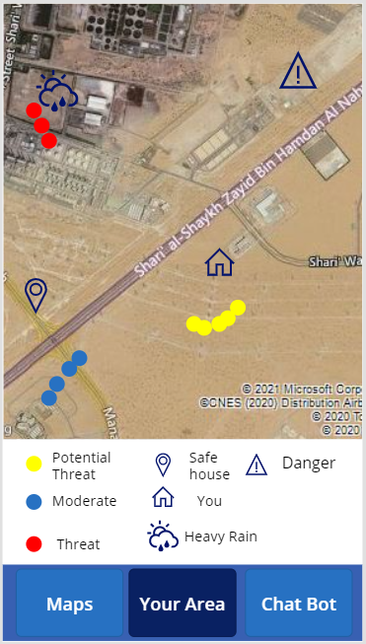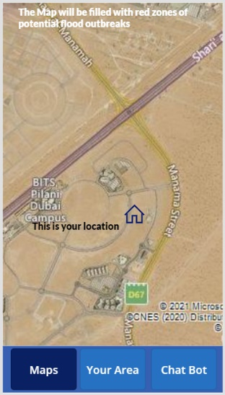

The data sets used here are by geofabric. Geofabric has 6 attributes Hydrology Reporting Regions, Hydrology Reporting Catchments, Surface Cartography, Surface Network, Surface Catchments, and Groundwater Cartography.